Week 3
Q1. Write a Python program to generate the first n Fibonacci numbers using a loop.
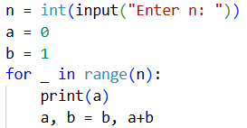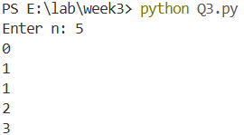
Q2. Write a Python program to count the number of vowels in a given string.
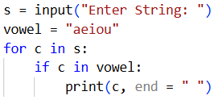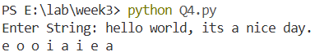

Problems based on HTML
Q3. Create the following table in HTML with Dummy Data:
